|  |
| --- |
| Poka Gamers |
| Meowth and his Pay Day |
| **2D Platformer** |
| Version #01  All work Copyright © 2016 by Poka Gamers.  All rights reserved. |
| **Bridgiet Dhivya Joseph** |
|  |

|  |
| --- |
| February 27th 2016 |

Table of Contents

Version History 3

Game Overview 4

Game Play Mechanics 4

Camera 4

Controls 4

Saving and Loading 4

Interface Sketch 5

Menu and Screen Descriptions 6

Game World 7

Levels 7

Characters 7

Enemies 7

Items 8

Script 8

Scoring 8

Sound Index 9

Art / Multimedia Index 10

Future Features 11

# Version History

This is the version 1 of this game.

# Game Overview

*‘Meowth’ is the player. He collects coins and amulets. The goal of the game is to reach the door and to collect as many coins and amulets as possible in addition to maintaining his health.*

# Game Play Mechanics

*Meowth is placed on a platform when he can walk and jump to collect coins, amulets and move to the next platform. He looses his health when he either falls down or collides with Murkrow his enemy. On colliding with Murkrow he also looses his coins. The player wins on reaching the final door.*

# Camera

*Focused on the player at the centre of the screen. It follows the player by keeping his focused throughout the Game.*

# Controls

*Left arrow / ‘a’ key – to move left*

*Right arrow / ‘d’ key – to move right*

*Up arrow / ’w’ key – to jump*

# Saving and Loading

*Game doesn’t include saving and loading*

# Interface Sketch

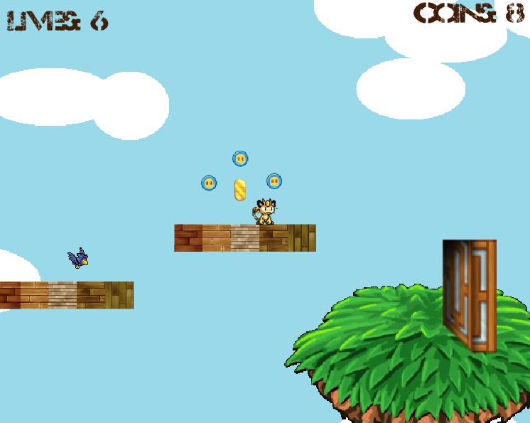

# Menu and Screen Descriptions

*The screen on game finish. It displays the overall score and a button to restart the game. It reads ‘Game Over’ if the player fails to finish the level or ‘Congrats on Winning’ if he reaches the door.*

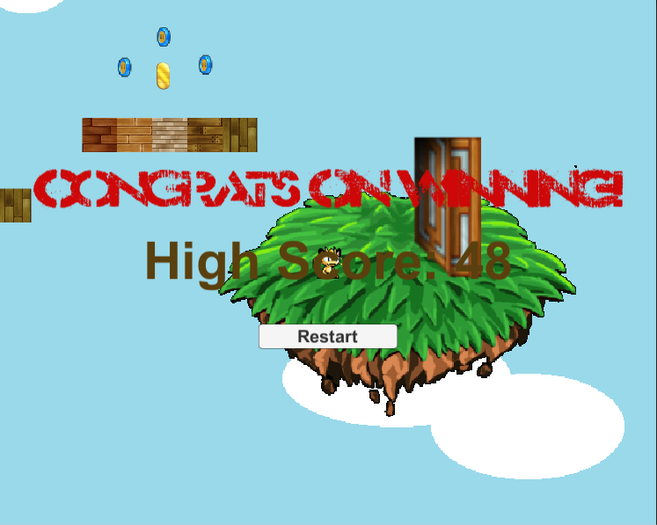

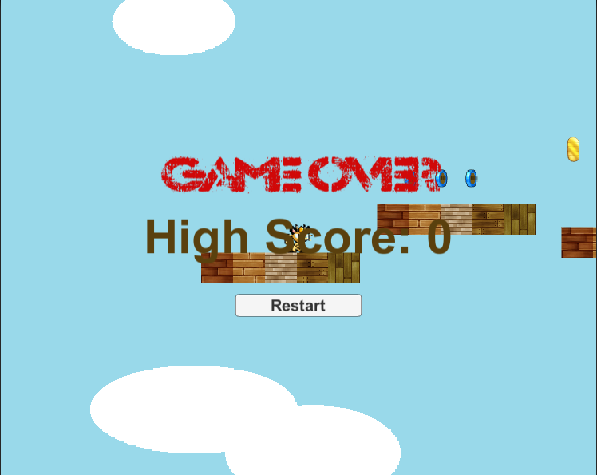

# Game World

*Background has clouds. The player jumps over platforms. The final destination is a floating ground on air with a door.*

# Levels

*A single level same with the goal to reach the door. The next version will include additional levels with increased difficulty.*

# Characters

Meowth:



*The player is Meowth from Pokemon animated series. He has an golden amulet on his head. When he collects amulets, he uses it for his special move. Amulets also doubles the coins the player wins. Meowth also loves shiny objects.*

# Enemies

Murkrow:

**

*Murkrow is also a Pokemon which loves shiny objects. Hence Murkrow is an enemy of Meowth.*

# Items

Coin:



Amulet:



# Script

*GameController – Controls the scoring, level completion and health.*

*MeowthController – Controls the actor including his collisions with other objects.*

*MurkrowController – Controls the enemy’s movement.*

*VelocityRange – Utility class.*

# Scoring

*The player gets one-coin point for every coin he collects.*

*The amulet doubles his collected coins and increases his health by one.*

*He looses his health by one if he falls down from the platform.*

*He looses his health by one and gets five coins taken away, if he collides with the enemy ‘Murkrow’. If he has less than five coins, all of his coins are taken away.*

*His overall score is the multiplied points got from his health and coins (health * coins)*

# Sound Index

|  |  |  |
| --- | --- | --- |
| *Index* | *Name* | *Description* |
| *1* | *Coin* | *Played when Meowth collides with a coin* |
| *2* | *GameOverAudio* | *Played when the player looses* |
| *3* | *Jump* | *Played when the player jumps* |
| *4* | *Life* | *Played when the player gains a health* |
| *5* | *MeowthScream* | *Played when the player looses a health* |
| *6* | *WinAudio* | *Played when the player wins the round* |

# Art / Multimedia Index

|  |  |  |  |
| --- | --- | --- | --- |
| *Index* | *Name* | *Type* | *Description* |
| *1* | *Coin* | *Animation* | *Coin rotation animation* |
| *1.1* | *Coin_1* | *Frame* | *Frame of Coin Animation* |
| *1.2* | *Coin_2* | *Frame* | *Frame of Coin Animation* |
| *1.3* | *Coin_3* | *Frame* | *Frame of Coin Animation* |
| *1.4* | *Coin_4* | *Frame* | *Frame of Coin Animation* |
| *1.5* | *Coin_5* | *Frame* | *Frame of Coin Animation* |
| *1.6* | *Coin_6* | *Frame* | *Frame of Coin Animation* |
| *2* | *Meowth_Fall* | *Animation* | *Meowth when he gets hurt* |
| *2.1* | *Fall_1* | *Frame* | *Frame of Meowth_Fall Animation* |
| *2.2* | *Fall_2* | *Frame* | *Frame of Meowth_Fall Animation* |
| *2.3* | *Fall_3* | *Frame* | *Frame of Meowth_Fall Animation* |
| *2.4* | *Fall_4* | *Frame* | *Frame of Meowth_Fall Animation* |
| *2.5* | *Fall_5* | *Frame* | *Frame of Meowth_Fall Animation* |
| *3* | *Meowth_Idle* | *Animation* | *Meowth when he is idle* |
| *3.1* | *Idle_1* | *Frame* | *Frame of Meowth_Idle Animation* |
| *3.2* | *Idle_2* | *Frame* | *Frame of Meowth_Idle Animation* |
| *4* | *Meowth_Jump* | *Animation* | *Meowth when he jumps* |
| *4.1* | *Jump_1* | *Frame* | *Frame of Meowth_Jump Animation* |
| *4.2* | *Jump_2* | *Frame* | *Frame of Meowth_Jump Animation* |
| *4.3* | *Jump_3* | *Frame* | *Frame of Meowth_Jump Animation* |
| *4.4* | *Jump_4* | *Frame* | *Frame of Meowth_Jump Animation* |
| *4.5* | *Jump_5* | *Frame* | *Frame of Meowth_Jump Animation* |
| *4.6* | *Jump_6* | *Frame* | *Frame of Meowth_Jump Animation* |
| *4.7* | *Jump_7* | *Frame* | *Frame of Meowth_Jump Animation* |
| *5* | *Meowth_Walk* | *Animation* | *Meowth when he walks* |
| *5.1* | *Walk_1* | *Frame* | *Frame of Meowth_Walk Animation* |
| *5.2* | *Walk_2* | *Frame* | *Frame of Meowth_Walk Animation* |
| *5.3* | *Walk_3* | *Frame* | *Frame of Meowth_Walk Animation* |
| *5.4* | *Walk_4* | *Frame* | *Frame of Meowth_Walk Animation* |
| *5.5* | *Walk_5* | *Frame* | *Frame of Meowth_Walk Animation* |
| *5.6* | *Walk_6* | *Frame* | *Frame of Meowth_Walk Animation* |
| *5.7* | *Walk_7* | *Frame* | *Frame of Meowth_Walk Animation* |
| *5.8* | *Walk_8* | *Frame* | *Frame of Meowth_Walk Animation* |
| *6* | *Murkrow_Attack* | *Animation* | *Murkrow when he attacks (Not Used)* |
| *6.1* | *Attack_1* | *Frame* | *Frame of Murkrow_Attack* |
| *6.2* | *Attack_2* | *Frame* | *Frame of Murkrow_Attack* |
| *7* | *Murkrow_Hurt* | *Animation* | *Murkrow when he is hurt* |
| *7.1* | *Hurt_1* | *Frame* | *Frame of Murkrow_Hurt* |
| *7.2* | *Hurt_2* | *Frame* | *Frame of Murkrow_Hurt* |
| *8* | *Murkrow_Move* | *Animation* | *Murkrow when he moves* |
| *8.1* | *Move_1* | *Frame* | *Frame of Murkrow_Move* |
| *8.2* | *Move_2* | *Frame* | *Frame of Murkrow_Move* |
| *9* | *Amulet* | *2D Sprite* | *Amulet* |
| *10* | *Background* | *2D Sprite* | *Background* |
| *11* | *Brick* | *2D Sprite* | *Platform* |
| *12* | *Level1_Destination* | *2D Sprite* | *The final destination with door* |

# Future Features

*Murkrow to be able to detect Meowth if he is within a certain range and to attack.*